CONFIDENTIAL  CS/MOCK 2026/ICT450

UNIVERSITI TEKNOLOGI MARA FINAL EXAMINATION

COURSE
COURSE CODE
EXAMINATION TIME
DATABASE DESIGN AND DEVELOPMENT
ICT450
MOCK 2026
3 HOURS

INSTRUCTIONS TO CANDIDATES

- This question paper consists of five (5) questions.

- Answer ALL questions in the Answer Booklet. Start each answer on a new page.

- Do not bring any material into the examination room unless permission is given by the invigilator.
- Please check to make sure that this examination pack consists of: i) the Question Paper
ii) an Answer Booklet - provided by the Faculty

- Answer ALL questions in English.

DO NOT TURN THIS PAGE UNTIL YOU ARE TOLD TO DO SO

This examination paper consists of 5 printed pages.

QUESTION 1
a) Define database, DBMS and database system.
(6 marks)
b) State FOUR limitations of the file-based approach that a DBMS addresses.
(8 marks)
c) Nusantara Learning Hub still keeps its customer records in a spreadsheet program. Table 1 shows a sample of the data. Study Table 1 and answer the following.
Table 1 : Sample data for a spreadsheet program
 | A | B | C | D | E
1 | Customer No | Customer IC | First Name | Last Name | e-mail
2 | 100 | 2021877889 | Abdul | Badri | a.abdul
3 | 101 | 2021755266 | Anwi | BenBrahim | e.anwi
4 | 102 | 2021522447 | Zainuddin | Hamid | zek90
5 | 103 | 2021369874 | Kayrie | Jamlus | j.kayrie
6 | 104 | 2021123698 | Huan | Ong | 4d40ng
7 | 105 | 2021339693 | Ishak | Sabarul | IS4u
8 | 106 | 2021745632 | Rita | Hasrul | DOH
i) Identify TWO candidate keys and ONE primary key from Table 1. Give ONE reason for your chosen primary key.
(3 marks)
ii) Explain why the spreadsheet in Table 1 is not a substitute for a database.
(3 marks)
QUESTION 2
a) Nusantara University keeps its student and course records in the tables shown below. Table 1 shows the STUDENT table and Table 2 shows the COURSE table. Identify the primary key of each table and TWO candidate keys in the STUDENT table.
Table 1: STUDENT table
STUDENT_IC | STUDENT_ID | FIRST_NAME | LAST_NAME | EMAIL | COURSE_ID
80193939979 | 202587788 | Ahmad | Ali | AA@gmail.com | 40
40122566748 | 202575526 | Haqiem | Rosly | haqiem@gmail.com | 40
20164723670 | 202552244 | Wany | Hazwan | wany@gmail.com | 50
10108990074 | 202536987 | Haliza | Husni | Ha@gmail.com | 50
80116756736 | 202512369 | Heechul | Kim | heechul@gmail.com | 40
90137476323 | 202533969 | James | Reece | james@gmail.com | 20
50143670971 | 202574563 | Canos | Sergi | Ola21@gmail.com | 20
Table 2: COURSE table
COURSE_ID | COURSE_NAME
10 | Networking
20 | Software Developer
30 | Web Designer
40 | Database Developer
50 | Data Analyst
60 | IT Professional
(4 marks)
b) Explain entity integrity and referential integrity. Give ONE example from Table 1 and Table 2.
(6 marks)
c) Define tuple, attribute, degree and cardinality.
(4 marks)
d) Explain TWO update anomalies that can occur in the STUDENT table if course details are stored together with student details.
(6 marks)
QUESTION 3
a) Figure 1 shows part of an ERD for a supplier and product database. Identify the entities, their attributes, the relationship between them and the cardinalities shown.
Figure 1 : Referential integrity in an Entity Relationship Diagram
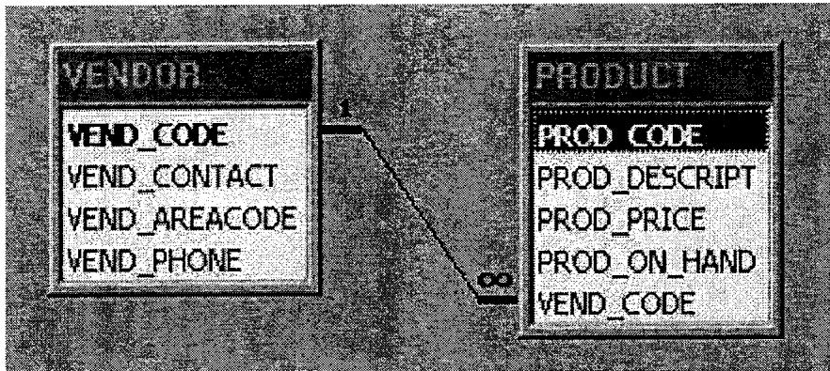
(8 marks)
b) Explain the referential integrity constraint shown in Figure 1. Give ONE example of an operation that would violate it.
(6 marks)
c) Map the ERD in Figure 1 to a relational schema. Mark the primary key and foreign key.
(6 marks)
QUESTION 4
a) The spreadsheet in Table 1 shows course and student records for a college. Study Table 1 and identify the candidate key and all functional dependencies.
Table 1 : Sample of college course information
Course Code | ICT450 | Course Name | Database Design and Development
Tutor ID | 306612 | Tutor Name | Professor Albus Dumbledore
Student ID | Student Name | DOB | Gender | Last Attendance Date
2016123456 | Luke Skywalker | 11.10.96 | F | 31.01.18
2016534363 | Kylo Ren | 12.12.96 | F | 15.01.18
2016788924 | Thor Loki | 27.06.96 | F | 31.01.18
2016329874 | Clint Barton | 31.08.96 | F | 17.01.18
2016324793 | General Hux | 23.05.96 | F | 23.01.18
2016479625 | Leia Organa | 17.02.96 | M | 15.01.18
2016328796 | Hermione Granger | 15.04.96 | M | 31.01.18
(4 marks)
b) Explain 1NF, 2NF and 3NF.
(6 marks)
c) Identify the partial and transitive dependencies in Table 1.
(4 marks)
d) Decompose Table 1 into 3NF relations. Show the primary and foreign keys.
(6 marks)
QUESTION 5
a) Figure 1 shows the database design process. Explain FOUR activities carried out during the database design phase.
Figure 1 : Database Design Process
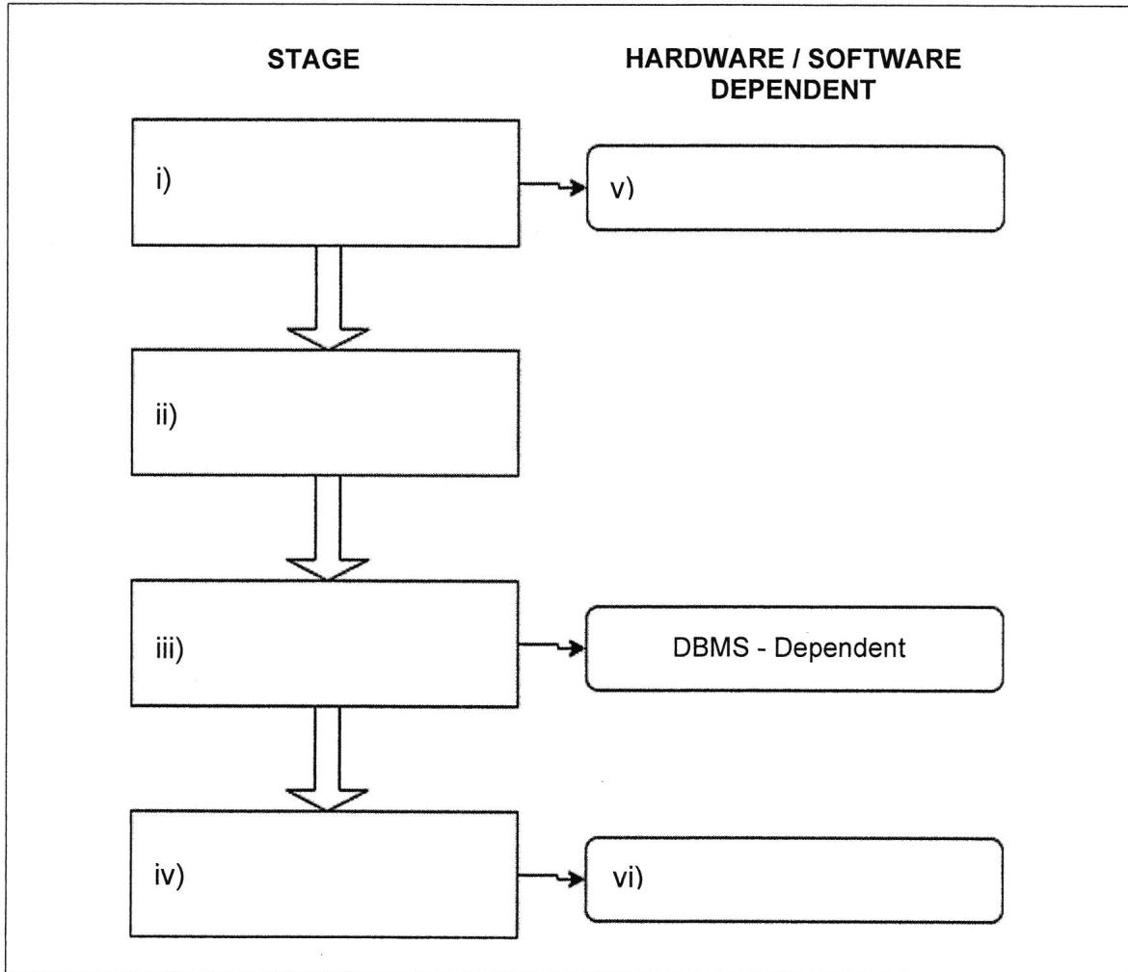
(8 marks)
b) Differentiate the SDLC and the DBLC.
(4 marks)
c) Compare top-down and bottom-up database design.
(4 marks)
d) Explain centralized and decentralized design.
(4 marks)
END OF QUESTION PAPER

